Project 3 Write up

Benjamin Berger

Bberger3@binghamton.edu

Methods:

Used

Got the intensity and put it in the red channel.

Went through the image and split the picture into sections of 8x8.

Within each 8x8, applied DCT using the DCT formula given.

Afterwards, stitched it all back together to make one image.

For the DC component, I only passed the first element in each 8x8. Everything else was passed as 0’s.

For the first nine, I only passed components where u <= 3 and v <= 3. Everything else was 0.

For the ROI, used a variance of the sobel filter to generate the gradients of the image. This produced regions that were interesting.

No real bugs to report at this time.

Solutions:

Part A

1) A person would see the hex color #80FF80. It is a very light (almost lime) green.

2) a) 85, 128, 43, 0, 255, 213, 22

b) 255, 0

c) 85, 170, 255, 0

3) a) would look like this (more square)



b) Will make the colors look more vibrant and brighter.

c) Will make the colors look closer to their base colors. The green will look a little greener. The teal will look a little closer to blues.

Part B

(I)

a) 11.625 0.742287 -0.239187 1.37407 0.265156 2.02077 0.577412 5.16078

15.0931 0.156536 -0.379455 0.829752 -0.127103 1.03611 0.416039 2.84178

b) (assume all one line)

11.625 -1.383 -0.239187 -1.14905 0.265155 -2.17109 0.577417 -5.03331 0.000245968 5.03338 -0.577438 2.17111 -0.265197 1.14913 0.239111 1.38316

c) Process b seems to have better compression. The sum is closer to the first number so you could keep the DC element and still have a good estimate of what you would find.

(II) (note that in pictures, some edges may have been snipped. Code works though)

instructions: make

a) ./p3-1 base1.bmp

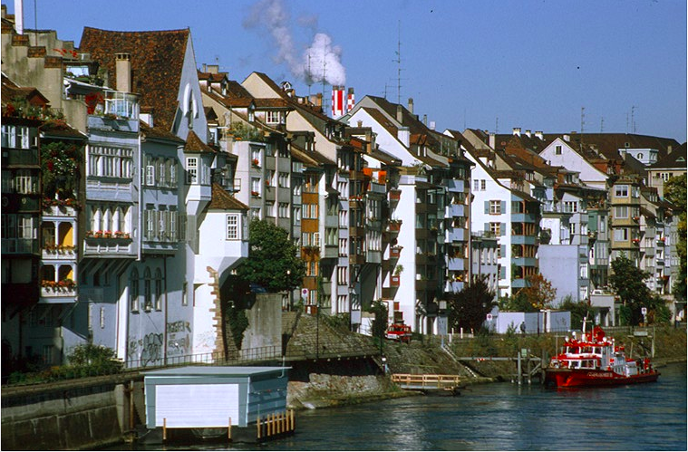

b) ./p3-2 base1.bmp (using hue divided by 360 for presentation)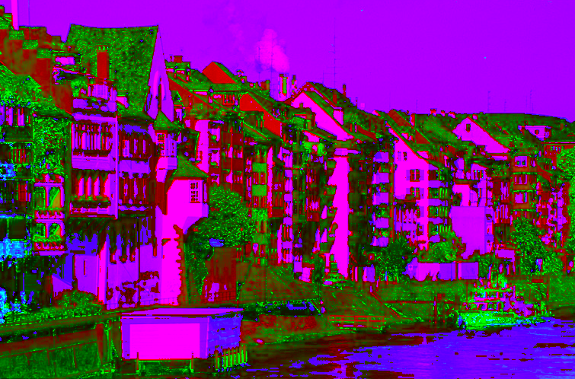

c) ./p3-3 base1.bmp (using the red channel for intensity)



d) ./p3-4 base1.bmp



e) ./p3-5 base1.bmp

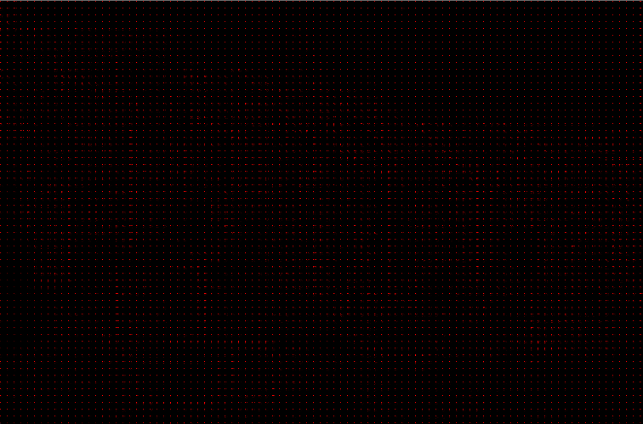

f) ./p3-6 base1.bmp (press spacebar twice to cycle through. Once for DC, again for first 9, and again for original).

DC image

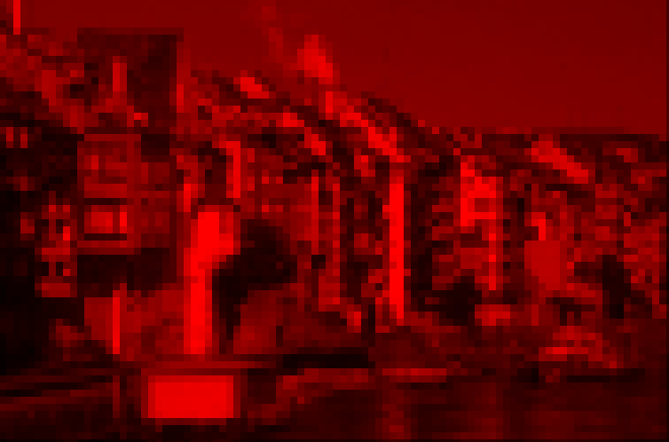

first 9

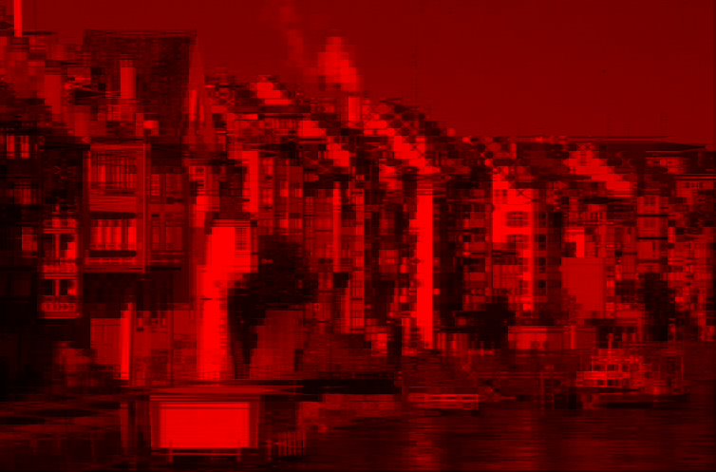

Part B, ROI

Used sobel gradients to generation ROI

./p3-7 Building.bmp

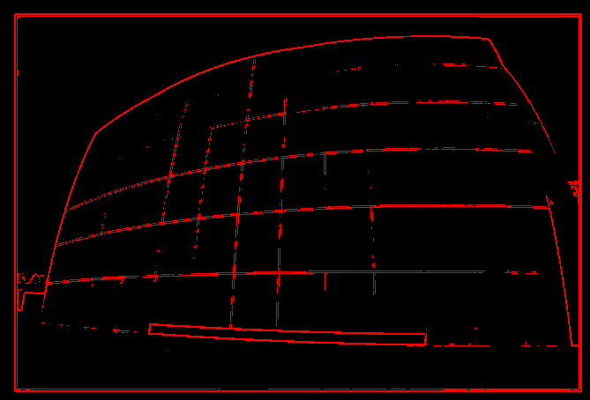

./p3-7 Disk.bmp

